**ITS 26000 – Applied Database Tech**

**Lab 06 – (100 points)**

**Note: Before you do the exercises of Lab 6, please reload the database scripts.**

**Use SQL to complete the following exercises.**

### KimTay Pet Supplies:

* 1. List the item ID, description, and on-hand value (units on hand * unit price) of each item in category CAT. (On-hand value is technically units on hand * cost, but there is no COST Column in the ITEM table.) Assign the name ON_HAND_VALUE to the computed column. (10 points)

select ITEM_ID, description, (ON_HAND * PRICE) as ON_HAND_VALUE

from item

where category = 'CAT';

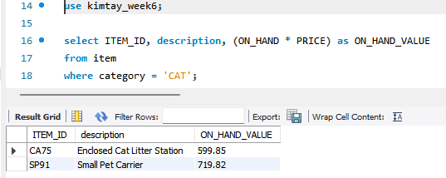

* 1. Use the IN operator to list the item ID and description of each item in category FSH or BRD. (5 points)

select item_id, description

from item

where category IN ('FSH', 'BRD');

* 1. Find the ID, first name, and last name of each customer whose first name begins with the letter “S.” (5 points)

select cust_id, first_name, last_name

from customer

where first_name LIKE 'S%';

* 1. How many customers have balances that are more than their credit limits? (10 points)

select count(cust_id)

from customer

where balance > credit_limit;

* 1. List the item ID, description, and on-hand value of each item whose number of units on hand is more than the average number of units on hand for all items. (Hint: Use a subquery.) (10 points)

select item_id, description, on_hand * price, on_hand

from item

where on_hand > (select avg(on_hand)

from item);

* 1. List the sum of the balances of all customers for each sales rep but restrict the output to those sales reps for which the sum is more than $150. Order the results by sales rep ID.v (10 points)

select sum(balance)

from customer

group by rep_id

having sum(balance) > '150'

order by rep_ID;

* 1. List the item ID and description of all items that are in the DOG or CAT category and contain the word “Small” in the description. (10 points)

select item_id, description

from item

where category IN ('DOG', 'CAT') and description like '%small%';

1. StayWell Student Accommodation:
2. List the property ID for every property managed by StayWell-Columbia City whose monthly rent is less than $1,500. (10 points)

select property_id

from property

where monthly_rent < '1500' and office_num =

(select office_num

from office

where office_name = 'StayWell-Colombia City');

1. List the owner number and last name for all owners who live in Nevada (NV), Oregon (OR), or Idaho (ID). (10 points)

select owner_num, last_name

from owner

where state in ('NV', 'OR', 'ID');

1. How many three-bedroom properties are managed by each office? (10 points)

select office_num, (property_id)

from property

where bdrms = 3

group by office_num;

1. Calculate the total value of monthly rents for all properties. (10 points)

select sum(monthly_rent)

from property;

**Deliverables**: Document Report with the SQL statement/Query and snapshot of query, its execution and results. Either word or pdf file need to be uploaded into Brightspace in one submission